**Project Title** -Sentiment analysis for customer feedback

**AIM**

This dataset aims to perform sentiment analysis on customer feedback. This dataset will help in understanding customer sentiments, identifying common themes, and correlating sentiment scores with customer satisfaction and other related metrics. It will also be used to build models that can predict customer satisfaction based on feedback and other variables. The inclusion of missing values, outliers, and non-summarized data will provide a realistic scenario for data cleaning and preprocessing, making it suitable for practical applications in sentiment analysis and customer feedback management.

**FEATURES**

* **Customer Feedback Data Structure**
* **Customer ID**: Unique identifier for each customer.
* **Feedback Date**: Date when the feedback was given.
* **Feedback Text**: Actual text of the feedback.
* **Sentiment Score**: Sentiment score of the feedback (ranging from -1 to 1).
* **Positive Mentions**: Number of positive mentions in the feedback.
* **Negative Mentions**: Number of negative mentions in the feedback.
* **Common Theme**: Common theme identified in the feedback (e.g., "product quality", "service", "delivery").
* **Customer Satisfaction**: Customer satisfaction score (ranging from 1 to 5).
* **Feedback Volume**: Volume of feedback provided by the customer.
* **Customer Age**: Age of the customer.
* **Customer Gender**: Gender of the customer (M/F/O).
* **Customer Location**: Location of the customer.
* **Purchase Frequency**: Frequency of purchases made by the customer.
* **Response Time**: Time taken to respond to the feedback (in hours).
* **Feedback Channel**: The Channel through which the feedback was received (e.g., email, phone, survey, etc,).

# METHODOLOGY:

1. Cleaning the raw data and filling the missing data
2. Summarizing the data
3. Importing data into Power BI
4. Creating a visualization
5. Analysing the visualization
6. Python file for data modeling

# OUTPUT:

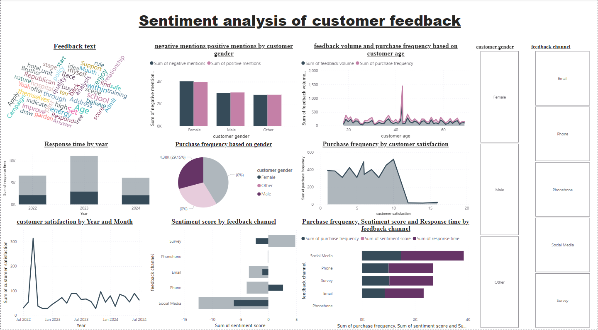

# RESULT ANALYSIS:

**Overview**

The dashboard presents a comprehensive analysis of customer feedback, focusing on sentiment, purchase behavior, and response times. It effectively utilizes various visualization techniques to convey insights.

**Key Insights**

### **Sentiment Analysis**

* **Negative mentions** are higher than positive mentions across all customer genders.
* **Word cloud** highlights common negative terms like "problem," "issue," and "bad," indicating areas for improvement.

### **Purchase Behavior**

* **Purchase frequency** is higher among female customers compared to male and others.
* **Purchase frequency** shows a slight upward trend over time.
* **Correlation between customer satisfaction and purchase frequency** is positive but not very strong.

### **Response Time**

* **Response time** has generally decreased over the years, indicating improvement in customer support.
* **Phone** channel has the highest response time compared to other channels.

### **Customer Satisfaction**

* **Customer satisfaction** has been fluctuating over the past year with no clear trend.
* **Survey** feedback channel consistently shows the highest customer satisfaction scores.

### **Additional Observations**

* **Feedback volume** is highest for the "Other" gender category.
* **Word cloud** also reveals positive mentions like "good," "great," and "excellent," indicating areas of strength.

**Potential Action Points**

* **Address negative sentiment:** Focus on understanding and resolving the root causes of negative feedback.
* **Improve response time:** Prioritize reducing response time, especially for the phone channel.
* **Enhance customer satisfaction:** Implement strategies to improve satisfaction scores, particularly for channels with lower ratings.
* **Analyze customer segments:** Conduct deeper analysis on customer segments to identify specific needs and preferences.
* **Track metrics over time:** Continuously monitor key metrics to measure the impact of improvement initiatives.

**Overall, the dashboard offers valuable insights into customer sentiment and behavior. By addressing the identified areas for improvement, businesses can enhance customer satisfaction and loyalty.**

# SUMMARY OF ANALYSIS:

The dashboard provides a snapshot of customer sentiment, purchase behavior, and response times. Key findings include:

* **Negative sentiment:** High prevalence of negative feedback, indicating areas for improvement.
* **Purchase behavior:** Purchase frequency is higher among females but shows a slight upward trend overall. Correlation between satisfaction and purchase frequency is weak.
* **Response time:** Improving over time, but phone channel lags behind others.
* **Customer satisfaction:** Fluctuating with no clear trend, highest for survey feedback channel.

Potential areas for improvement include addressing negative sentiment, optimizing response times, and enhancing overall customer satisfaction through deeper analysis and targeted actions.